PROGRAMMING IN JAVA PROJECT REPORT
Course Code: CSE2006
Course Title: Programming in java
Submitted by:
Name: Jeeya
Registration Number: 25BAI10808
Branch: B.Tech [AIML]
Year: Second Year
Institution: VIT Bhopal University
Submission Date: 18-09-2026

Expense Tracker Project Report
1. Introduction
The Expense Tracker is a Java-based console application designed to help users manage their daily expenses. It allows users to enter expense details such as description, category, and amount.
The application provides useful operations including:
- Adding a new expense.
- Viewing all expenses.
- Calculating total expenses.
- Searching expenses by category.
- Deleting an expense.
This project demonstrates important Java concepts such as classes, objects, encapsulation, ArrayList, methods, loops, switch statements, input validation, and exception handling.

2. Problem Statement
People often spend money on food, travel, shopping, education, and other activities without maintaining a proper record. As a result, they may not know how much money they have spent or which category consumes the most money.
The problem is to develop a simple application that allows users to record and manage their expenses efficiently. The application should provide a clear way to add, display, calculate, search, and delete expense records.

3. Functional Requirements
Functional requirements describe what the system should do.
3.1 Display menu
The system should display a menu containing all available operations:
1. Add Expense
2. View All Expenses
3. Show Total Expense
4. Search by Category
5. Delete Expense
6. Exit
3.2 Add expense
The user should be able to enter:
- Expense description.
- Expense category.
- Expense amount.
Example:
Description: Lunch
Category: Food
Amount: ₹120
3.3 View expenses
The application should display all stored expenses with:
- Serial number.
- Description.
- Category.
- Amount.
3.4 Calculate total expense
The system should calculate the sum of all expense amounts.
For example:
Lunch: ₹120
Bus fare: ₹40
Total: ₹160
3.5 Search by category
The user should be able to search expenses using a category such as:
- Food.
- Travel.
- Shopping.
- Education.
- Entertainment.
The application should display all expenses belonging to the selected category.
3.6 Delete expense
The user should be able to delete an expense by entering its serial number.
3.7 Validate input
The application should reject:
- Empty descriptions.
- Empty categories.
- Negative amounts.
- Zero amounts.
- Invalid menu choices.
- Letters entered where numbers are expected.

4. Non-functional Requirements
Non-functional requirements describe how the system should work.
4.1 Usability
The application should have a simple menu and clear instructions so that a beginner can use it easily.
4.2 Performance
The system should respond quickly to normal user operations. Since the application is designed for personal use, it does not need to handle a very large number of records.
4.3 Reliability
The program should not terminate unexpectedly when the user enters invalid data. It should display an error message and request valid input again.
4.4 Maintainability
The code should be divided into separate classes and methods so that future modifications are easy.
4.5 Portability
The program should run on any operating system that has a compatible Java Development Kit installed.
4.6 Security
The current version does not use login or password protection. It is intended as a local learning project and does not store sensitive financial information.

5. System Architecture
The application uses a simple layered architecture.
5.1 User interface layer
This layer interacts with the user through the console. It:
- Displays menus.
- Accepts keyboard input.
- Displays results and error messages.
The Scanner class is used to read input.
5.2 Application logic layer
This layer performs the main operations:
- Adding expenses.
- Calculating totals.
- Searching categories.
- Deleting records.
- Validating input.
The ExpenseTracker class contains most of this logic.

5.3 Data model layer
This layer represents one expense. The Expense class stores:
- Description.
- Category.
- Amount.
5.4 Architecture diagram
+-------------------------+
| User |
+------------+------------+
|
v
+-------------------------+
| Console Interface |
| Scanner and Menu |
+------------+------------+
|
v
+-------------------------+
| ExpenseTracker Class |
| Application Logic |
+------------+------------+
|
v
+-------------------------+
| Expense Class |
| Description, Category, |
| Amount |
+------------+------------+
|
v
+-------------------------+
| ArrayList<Expense> |
| Temporary Data Storage |
+-------------------------+

6. Design Diagrams
6.1 Use-case diagram
The main actor is the User.
+--------------------------+
| Expense Tracker |
|--------------------------|
User ------------------> | Add Expense |
User ------------------> | View All Expenses |
User ------------------> | Show Total Expense |
User ------------------> | Search by Category |
User ------------------> | Delete Expense |
User ------------------> | Exit Application |
+--------------------------+
6.2 Class diagram
+--------------------------------+
| Expense |
+--------------------------------+
| - description: String |
| - category: String |
| - amount: double |
+--------------------------------+
| + Expense(...) |
| + getDescription(): String |
| + getCategory(): String |
| + getAmount(): double |
| + displayExpense(): void |
+--------------------------------+

used by

+--------------------------------+
| ExpenseTracker |
+--------------------------------+
| - scanner: Scanner |
| - expenses: ArrayList<Expense> |
+--------------------------------+
| + main(): void |
| + displayMenu(): void |
| + addExpense(): void |
| + viewExpenses(): void |
| + showTotalExpense(): void |
| + searchByCategory(): void |
| + deleteExpense(): void |
| + readInteger(): int |
| + readDouble(): double |
+--------------------------------+

6.3 Flowchart
Start
|
v
Display main menu
|
v
Read choice
|
+------+------+
| |
Choice 1 Choice 2
Add expense View expenses
| |
+------+------+
|
Choice 3: Calculate total
|
Choice 4: Search category
|
Choice 5: Delete expense
|
Choice 6?
/ \
Yes No
| |
Exit Display menu again

6.4 Add-expense flow
Start add operation
|
v
Enter description
|
v
Is description empty?
/ \
Yes No
| |
Show error Enter category
|
v
Enter amount
|
v
Is amount valid?
/ \
No Yes
| |
Show error Add expense
|
v
Show success message

7. Design Decisions and Rationale
7.1 Use of an Expense class
A separate Expense class represents one expense record. This keeps related data together and follows object-oriented programming principles.
7.2 Use of ArrayList
ArrayList is used because the number of expenses can change during program execution. It supports:
- Adding records.
- Accessing records.
- Removing records.
- Iterating through records.
7.3 Console interface
A console interface was chosen because:
- It is simple to implement.
- It does not require external libraries.
- It is suitable for beginners.
- It focuses on programming logic.
7.4 Encapsulation
The fields in the Expense class are declared as private. They are accessed using public getter methods. This protects the data from direct modification.
7.5 Separate methods
Each operation has its own method, such as:
addExpense()
viewExpenses()
showTotalExpense()
searchByCategory()
deleteExpense()
This makes the program easier to understand, debug, and extend.
7.6 Input validation
Input validation is included to prevent incorrect data from entering the system. For example, the amount must be greater than zero.

8. Implementation Details
The project is implemented using Java.
8.1 Expense class
The Expense class contains three properties:
private String description;
private String category;
private double amount;
The constructor initializes these values:
public Expense(String description, String category, double amount) {
this.description = description;
this.category = category;
this.amount = amount;
}
Getter methods are used to retrieve values:
public String getDescription() {
return description;
}

public String getCategory() {
return category;
}

public double getAmount() {
return amount;
}
8.2 Expense list
All expenses are stored in an ArrayList:
static ArrayList<Expense> expenses = new ArrayList<>();
8.3 Adding an expense
The application reads the description, category, and amount from the user and creates an Expense object:
expenses.add(new Expense(description, category, amount));
8.4 Calculating total
The total is calculated by looping through every expense:
double total = 0;

for (Expense expense : expenses) {
total += expense.getAmount();
}
8.5 Searching by category
The equalsIgnoreCase() method allows the user to search without worrying about uppercase or lowercase letters:
if (expense.getCategory().equalsIgnoreCase(category)) {
expense.displayExpense(i + 1);
}
Thus, Food, food, and FOOD are treated as the same category.
8.6 Deleting an expense
The user enters an expense number. Since Java list indexes start from zero, one is subtracted:
expenses.remove(expenseNumber - 1);
8.7 Exception handling
The program uses try-catch to handle invalid numeric input:
try {
return Double.parseDouble(scanner.nextLine());
} catch (NumberFormatException exception) {
System.out.println("Please enter a valid amount.");
}

9. Screenshots and Results
Input:
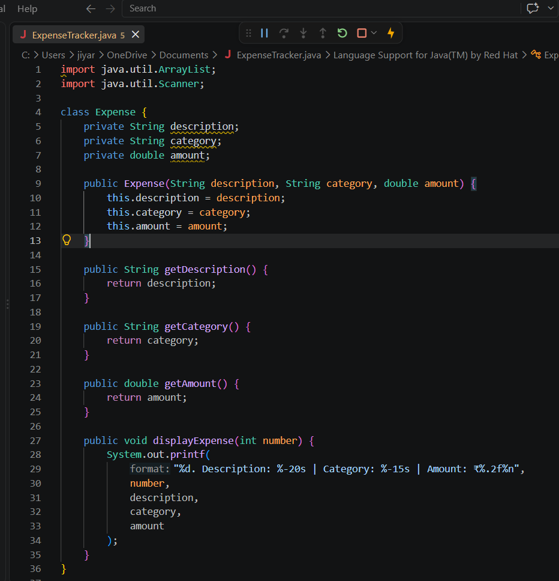
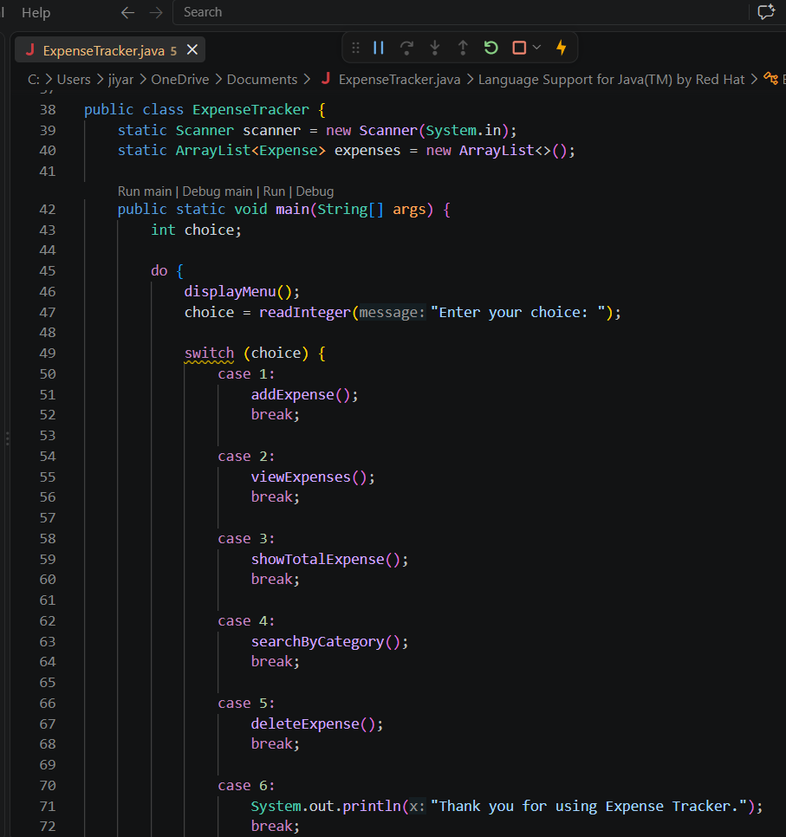
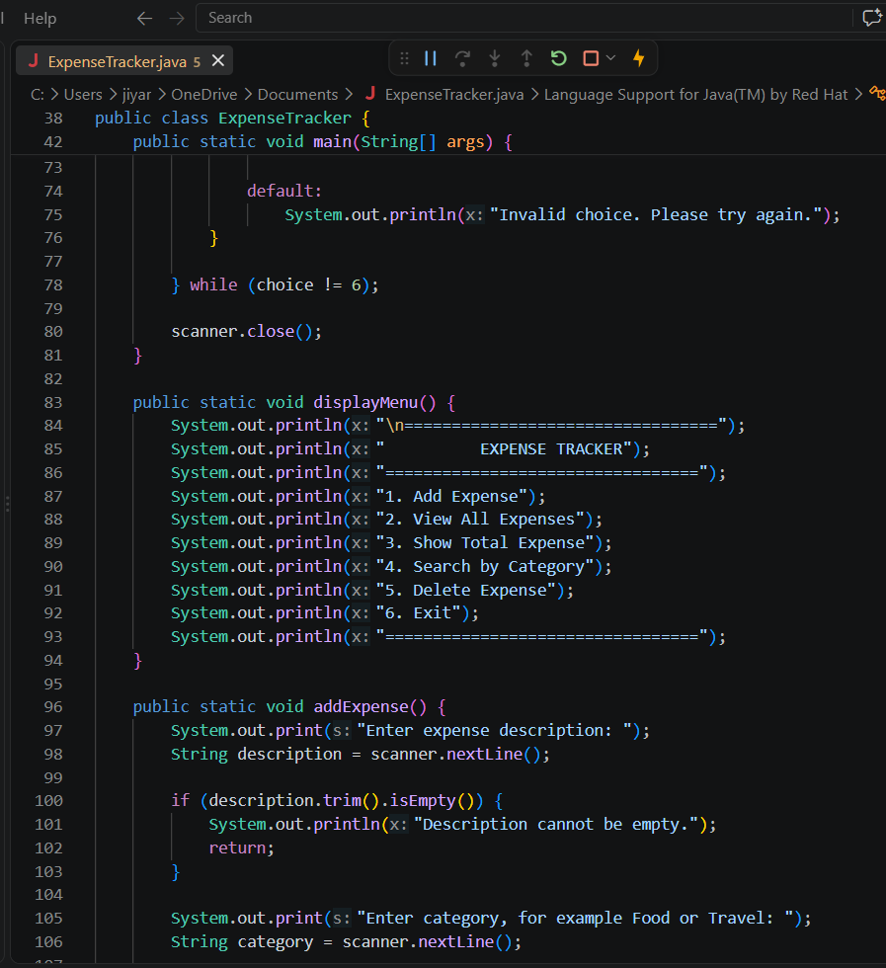
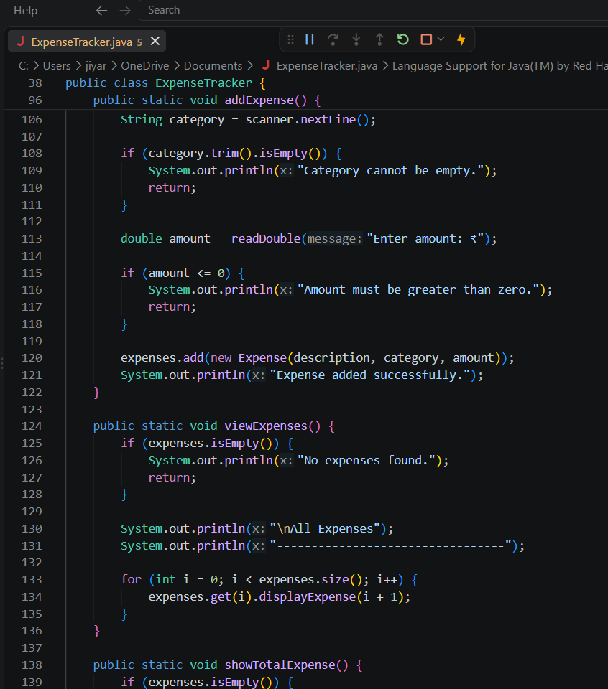
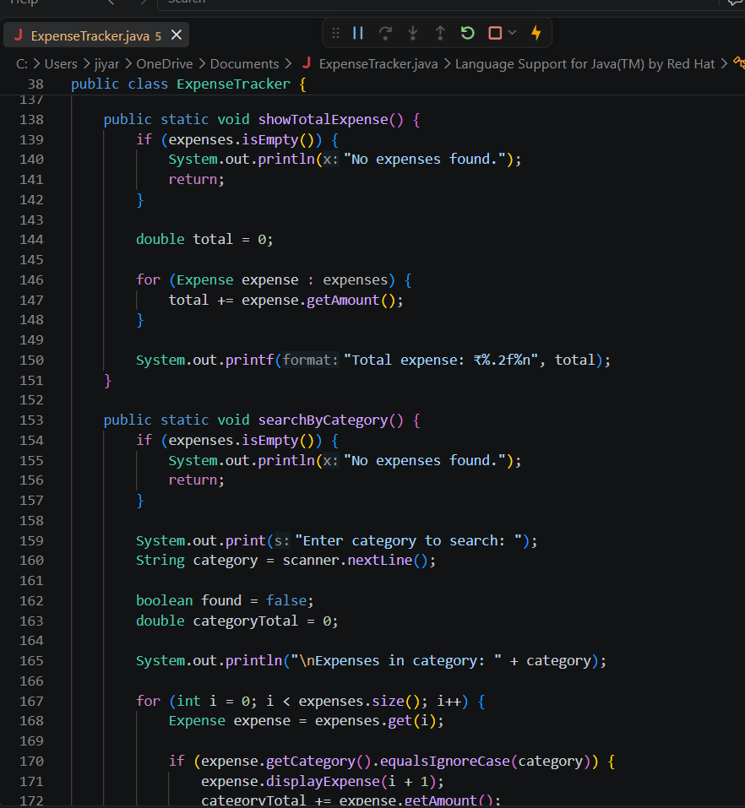
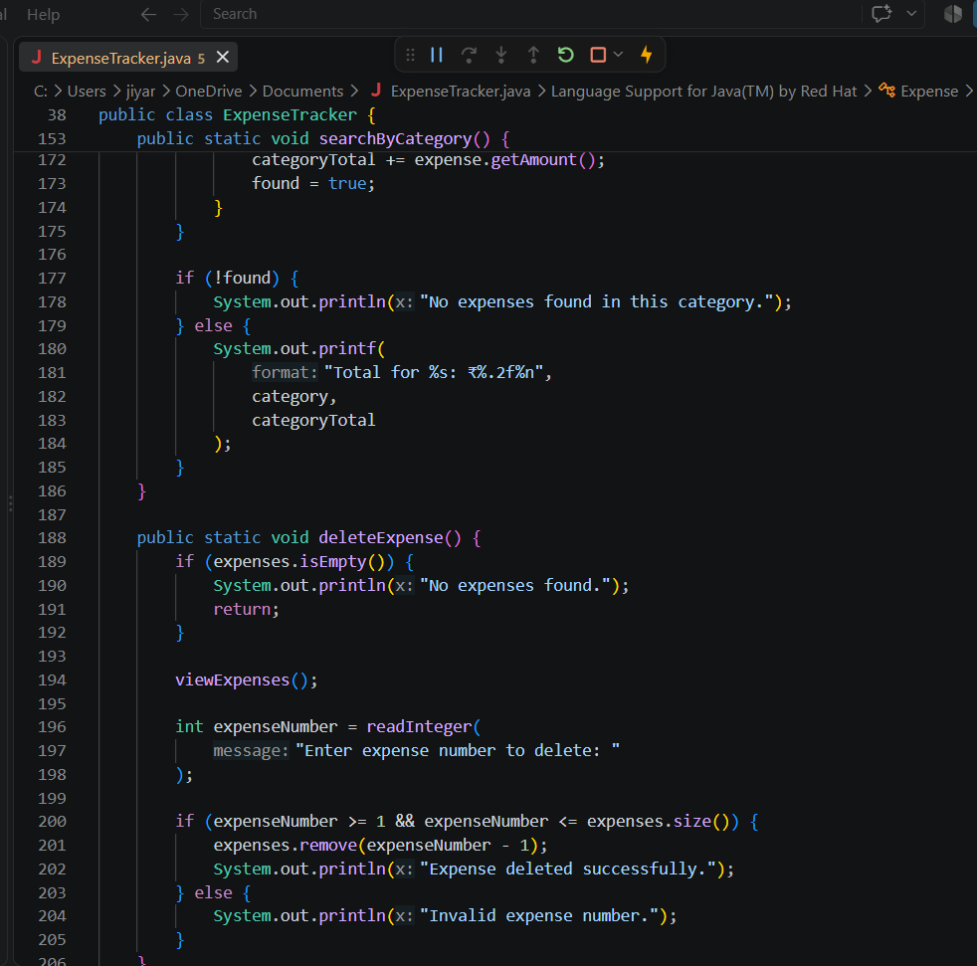
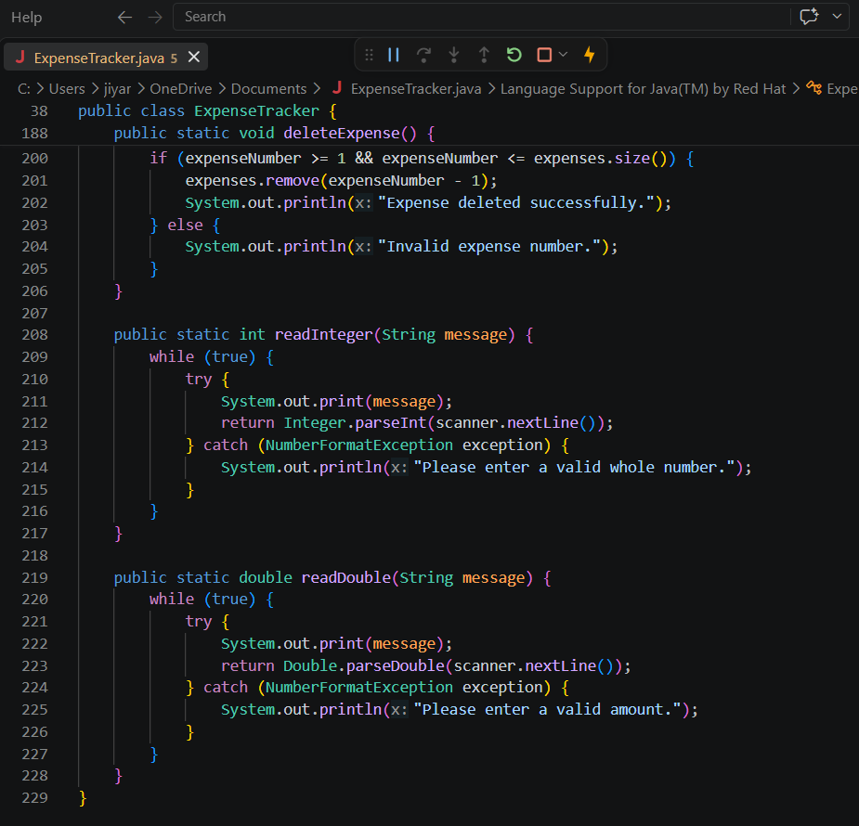

Output:
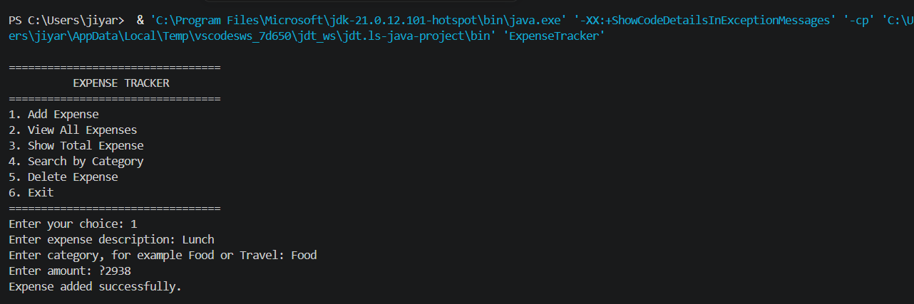
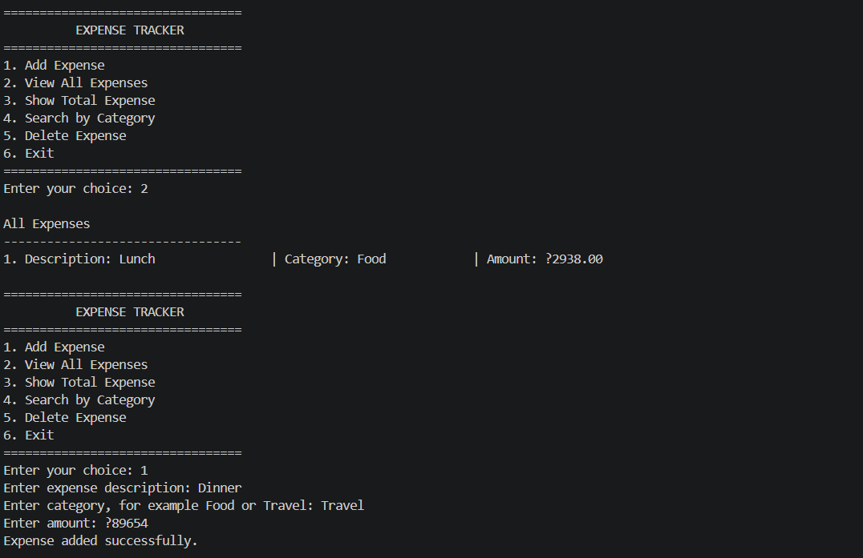

10. Testing Approach
The application was tested using functional testing. Each operation was checked with valid and invalid inputs.
Test case | Input or action | Expected result
Add valid expense | Lunch, Food, 120 | Expense is added successfully
Empty description | Blank description | Error message is displayed
Empty category | Blank category | Error message is displayed
Zero amount | 0 | Expense is rejected
Negative amount | -50 | Expense is rejected
Invalid amount | abc | Program asks for a valid amount
View expenses | Select option 2 | All expenses are displayed
Calculate total | Expenses of 120 and 40 | Total is displayed as 160
Search category | Enter Food | Food expenses are displayed
Search unavailable category | Enter Medical | No matching expense message
Delete valid expense | Enter valid serial number | Expense is deleted
Delete invalid expense | Enter number outside list | Invalid number message
Invalid menu option | Enter 9 | Invalid choice message
Exit application | Select option 6 | Program terminates
Testing result
The basic features worked correctly for valid inputs. Invalid text, empty values, negative amounts, and incorrect menu choices were handled using validation and error messages.

11. Challenges Faced
11.1 Handling user input
The program accepts both text and numeric input. Managing these inputs correctly using Scanner required careful handling.
11.2 Handling invalid numbers
Users may enter letters instead of numbers. This can cause a NumberFormatException. The issue was handled using try-catch.
11.3 Maintaining list indexes
The displayed expense number starts at 1, but ArrayList indexes start at 0. Therefore, the program uses:
expenseNumber - 1
when deleting a record.
11.4 Category comparison
Users may enter categories using different capitalization. The equalsIgnoreCase() method was used to solve this problem.
11.5 Temporary data storage
The current application stores expenses only while it is running. All data is lost when the program closes. Permanent storage would require file handling or a database.
11.6 Organizing code
Separating the data model and application operations into appropriate classes and methods required understanding object-oriented design.

12. Learnings and Key Takeaways
Through this project, the following concepts were learned:
- How to create Java classes and objects.
- How to use constructors.
- How to apply encapsulation.
- How to use private fields and getter methods.
- How to store objects in an ArrayList.
- How to create menu-driven applications.
- How to use loops and switch statements.
- How to create reusable methods.
- How to validate user input.
- How to handle exceptions.
- How to perform CRUD-like operations.
- How to calculate totals from stored data.
- How to search objects based on a property.
- How to design a simple software architecture.
- How to test a program using different test cases.
The project also demonstrates how a small Java program can be gradually developed into a larger real-world application.

13. Future Enhancements
13.1 File handling
Expenses can be saved in a text or CSV file so that records remain available after the application closes.
13.2 Database connectivity
The application can be connected to MySQL or SQLite using JDBC for permanent and structured storage.
13.3 Graphical user interface
Java Swing or JavaFX can be used to create a visual interface with buttons, text fields, tables, and charts.
13.4 Date support
Each expense can include:
- Date.
- Time.
- Month.
- Year.
This would allow monthly and yearly reports.
13.5 Budget management
The user could set a monthly budget and receive a warning when expenses exceed the limit.
13.6 Expense categories
The system could provide predefined categories such as:
- Food.
- Travel.
- Education.
- Shopping.
- Medical.
- Entertainment.
- Bills.
13.7 Reports and charts
The application could display:
- Category-wise spending.
- Monthly expense trends.
- Highest expense.
- Average daily expense.
13.8 Login system
A login system could allow multiple users to maintain separate expense records.
13.9 Export functionality
Reports could be exported to CSV, Excel, or PDF format.
13.10 AI-based prediction
As a future AI/ML enhancement, the system could predict future expenses using historical spending data.

14. References
- Oracle Java documentation for classes, objects, collections, exception handling, and input handling.
- Java documentation for the ArrayList class.
- Java documentation for the Scanner class.
- GitHub, “ExpenseTracker: A simple Java console-based Expense Tracker.”
- GitHub, “Expense-Tracker-Java,” demonstrating add, search, delete, sorting, and file storage features.
- JavaGuides, “Building a Simple Expense Tracker in Java,” covering ArrayList and file operations.

